Introduction:
"Birthday" the only day in your life... your mother smiles when you cried.” - Dr. A.P.J. Abdul Kalam

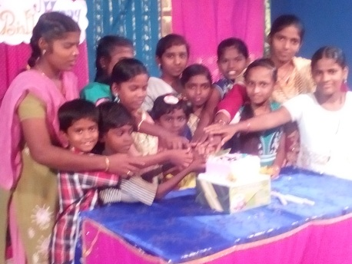
The above mentioned quote clearly tells us all how important it is celebrate our birthday. Our birthday celebration reminds us of our purpose in life. Everyone is born for a reason and fulfill certain destiny which can never be replaced by anyone else. The occasion of birthday celebration gives us all chance to thank the beautiful life we are blessed with and gives us a feel of becoming elder and wiser. On considering all the reasons one could understand how vital it is to celebrate birthdays.
Birthday Celebration:
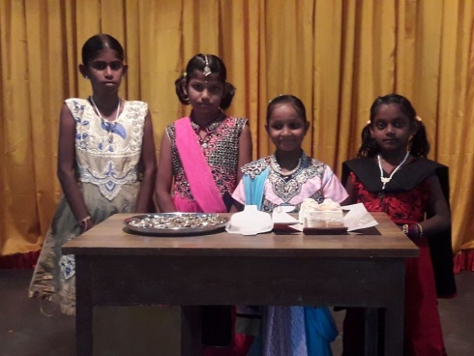
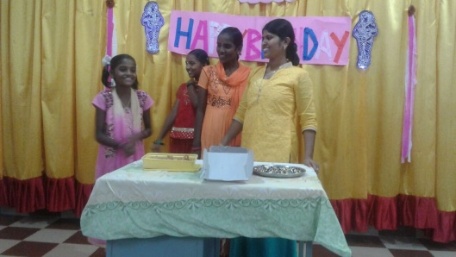
As you know very well that the children we have in our institutions are from very poor background and seldom had they chances to celebrate their birthdays before coming to the institute. When they see other children who come to school from their houses and when they celebrate their birthdays our children tend to get the feel that there is no one to care for them. There is no one to celebrate their birthdays. We observed that and wanted to confirm them that St. Joseph’s Development Trust always cares for them. So we started celebrating the children’s birthday in our institute. On the last date of a month the children who celebrated their birthdays in that particular month are called together and they celebrate their birthday in the midst of whole children. They wear new dress and adorn themselves with flowers and make up. The smile we get from them on that day would not equalize with any sort of happiness. Such will be their joy and happiness. Through this celebration they feel loved and experience tremendous confidence about their lives.
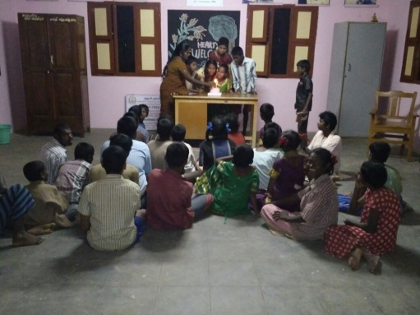
We could sense a change in them all after the celebration. They start loving themselves and the others too because some of them had a negative idea about relationship, friends and neighbors as they did not have proper family situation. This birthday celebration does definitely change them a lot and get along well with others a lot. The celebration makes them feel special.
Usually the celebration starts at 07:00 PM. All the children are assembled in a common place and the celebrants are invited in front. All of them blow the candles that are lit on the cake. Then they all cut the cake and give to each other and greet one another while the rest of them sing birthday songs joyfully. Once the celebrants finish greeting one another they distribute chocolates to all the children. The children organize special prayer service before cake cutting for welfare and educational progress of the celebrants.
Conclusion:
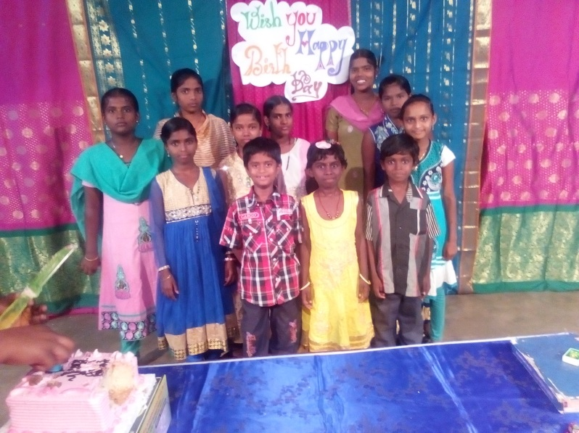
We witness vast change and happiness in the lives of the children through this practice. It keeps them motivated to achieve their goal and feel loved. We are so happy to keep these children happy with all ways and means. Since we find this program to be more effective to keep these children happy we continue doing it. Eventually it is with your great support we are able to do all the activities and organize such programs for the welfare of the children. The children who reside in our entire institute and those who work the betterment of these children warmly thank you for all your benevolent support and hope you would keep extending your support in the coming years too.

